Q1) Implement a program in CUDA which performs convolution operation on one dimensional input array N of size width using a mask array M of size mask_width to produce the resultant one-dimensional array P of size width.
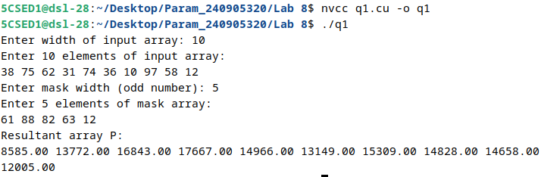

Q2)Implement a program in CUDA to perform odd even transposition sort in parallel.
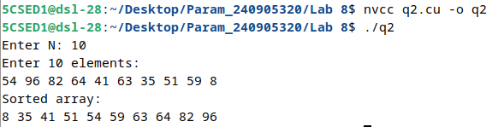

Q3)Implement a program in CUDA to perform parallel rank sort in parallel.
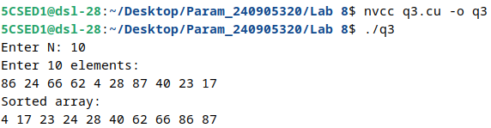
Q4)Implement a program in CUDA to count the number of times a given word is repeated in a sentence. (Use Atomic function)
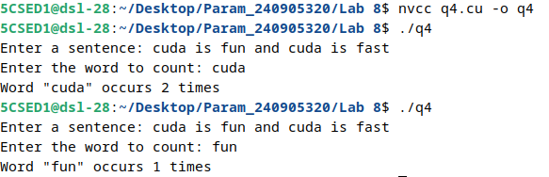

Q5)Implement a CUDA program that reads a string and replaces every vowel with "*". Use appropriate atomic function to replace the character with *.

